UTILIZING ‘LISTEN ENGLISH DAILY PRACTICE’ APPLICATION IN LISTENING COMPREHENSION CLASSROOM

Elsa Monica¹, Lidiyatul Izzah²
^{,1,2}Universitas Muhammadiyah Jakarta
¹Email: elsamonica907@gmail.com, lidiyatul.izzah@umj.ac.id
©2020 by the authors. Submitted for possible open access publication under the terms and conditions of the Creative Commons
Attribution-ShareAlike 4.0 International License-(CC-BY-SA) (https://creativecommons.org/licenses/by-sa/4.0/)
DOI :

Submission: date, month, year | Revised: date, month, year | Published: date, month, year
Abstrak

Penelitian ini bertujuan untuk mengukur efektivitas dari aplikasi Listen English Daily Practice (LEDP) pada peningkatan keterampilan pemahaman menyimak siswa kelas 8. Terdapat 34 orang siswa dalam 1 kelas yang dilibatkan sebagai sampel. Penelitian ini menggunakan metode kuantitatif dengan pendekatan ekperimen dan disain one group pre-test post-test. Dalam mengumpulkan data, 20 pertanyaan pilihan berganda pada pre-test dan post-test digunakan sebagai instrument dengan terlebih dahulu meminta siswa untuk menyimak topik percakapan yang peneliti ambil dari YouTube. Analisa data statistic paired-sample test digunakan dalam menganalisa data. Hasil Analisa tersebut menunjukkan capaian nilai rerata siswa pada post-test (82,20) lebih tinggi daripada nilai rerata pre-test (49,70). Selain itu, perhitungan menggunakan paired-sample test menunjukkan bahwa standar rerata kesalahan pada pre-test asalah 1,606, sedangkan pada post-test adalah 1,371. Hal ini berarti kesalahan siswa pada post-test lebih rendah daripada pre-test. Korelasi antara LEDP sebagai variabel X dengan keterampilan pemahaman menyimak sebagai variabel Y yang dihitung melalui paired-sample correlations menunjukkan nilai signifikan 0,01 lebih rendah dari 0,05 (Sig. 0,01<0,05) yang berarti terdapat korelasi antara kedua variabel tersebut. Dengan demikian, hasil penelitian ini menolak H₀ dan menerima Ha. Sebagai kesimpulan, LEDP merupakan aplikasi yang efektif dalam meningkatkan keterampilan pemahaman menyimak siswa.
Kata Kunci: aplikasi LEDP, pemahaman menyinak, aplikasi sebagai media ajar
Abstract
This research was aimed to measure the effectiveness of Listen English Daily Practice (LEDP) application in the improvement of 8th graders’ listening comprehension skills. There were 34 students comprised in one class involved as the sample of this study. This research used quantitative method with experimental approach and one-group pretest post-test design. In collecting the data, 20 multiple-choice questions in the pre-test and post-test were used as the instruments after the students were instructed to listen to conversation videos taken from YouTube. Data analysis of paired sample test was used in analyzing the data. That data analysis showed that the average score gained by the students in the post-test (82.20) was higher than the one in the pre-test (49.70). Besides, the calculation by using paired-sample test revealed that the standard error mean made by the students in the pre-test was 1.606 while in the post-test was 1.371. These findings showed that the errors made by the students in the post-test was smaller than in the pretest. The correlations between LEDP application as variable X and students’ listening comprehension skills as variable Y computed through paired-sample correlations indicated significant value of 0.01 which was lower than 0.05 (Sig. 0.01<0.05); meaning that the two variables were correlated. Therefore, this research rejected H₀ and accepted Ha. To conclude, LEDP was an effective application utilized in improving students’ listening comprehension skills.
Keywords: LEDP application, listening comprehension, application as teaching media

Introduction
“Listening skill is very important in foreign language learning because the key to learn a language is to receive language input” (Gilakjani & Sabouri, p. 1670). The learners who have good listening skill will be easier to understand any comprehensible input to support the process of their language learning and the development of other language skills. Conversely, without having the ability to grasp sufficient understandable input, language acquisition will be hampered. In EFL classroom, Bano (2017) said, many researchers believed that two most important skills are listening, then speaking. She further explained that this due to the fact in which the more the learners understand, the more confident they become to use the language, and this understanding can only be acquired by them through their ability to listen to input. Therefore, serious thoughts and study are needed to help second language learners dealt with complex nature of listening skills and difficulties (Kim, 2015).

In accordance with this, Kim (2015) further said that listening is a process that involves a deeper understanding of the meaning, it is not a simple word-by-word translation process. In listening, students are dealing with genuine conversations and real situations which requires them to understand those actual speech. At this point, teacher’s role to facilitate and provide the students with appropriate and effective ways of teaching is needed. According to Vega (2016), in order to foster and equip the learners to be successful in listening comprehension, teachers should update their teaching approaches and methodologies adjusted to the purpose of each subject discussion. This means that any strategy taken by the teachers should be adapted to current situations to make the learning more meaningful.

Shaping with this technological era, utilizing any application linked by the internet can be chosen by the teachers to support their listening classroom. As Vahdat & Eidipour (2016) opined that due to various issues in English classrooms including limited time, lack of proficient teachers, inadequate materials and sources, and learners’ anxiety, building interesting learning atmosphere is one of suggested strategies to solve these problems. In responding to this idea, In Indonesia, plethora of prior studies have been focusing on the utilization of various application in listening comprehension classrooms, such as: the use of YouTube video (Qomariyah, 2021; Sondy & Mandasari, 2023; Audina, et.al., 2022; Yuyun & Simamora, 2021), Spotify application (Silvi & Nurjati, 2023); Dailymotion application (Emilia, et.al, 2023); Podcasts (Ningtias, 2021; Abdulrahman, et.al., 2018), DuoLingo and SPADA (Purwanto, et.al, 2022). Among those numerous numbers of application, the one which discussed ‘Listen English Daily Practice (LEDP) application was still scarce. Therefore, this research was aimed to explore the use of this application in teaching listening comprehension to the students, to fill the gap.

It is reviewed on: https://www.educationalappstore.com/app/listen-english-daily-practice, that LEDP is a free downloaded application to practice listening skills. This application provides listening materials for every level; beginner, intermediate, and advanced. Most of the materials contain everyday topics and short stories with huge number of conversational and useful vocabulary hence the learners can practice every time they need to develop and improve their listening skills. This application benefits both students and the teachers in which the students can easily start their listening practice while the teachers can grasp their skills and knowledge to select the best ways to teach the students. Nurussyifa & Izzah (2022) reported on their experimental research findings that LEDP was not only an effective media to encourage 8th graders’ motivation to study English, but also affected the improvement of their listening skills. In order to measure the effectiveness of this application, the researchers used two groups of 8 grade students as experimental and controlled group. It was proven that the class which did not use this application in their listening class did not perform as good as the experimental one.

Referring to the background above and the gap the researchers found from plethora of prior studies, this research was then guided by a research question: “Is Listening English Daily Practice an effective application to be utilized to improve students’ listening comprehension skills?” Thus, the objective of this research was to scrutinize whether or not this LEDP application effective to be used by the teachers to improve listening comprehension skills of the students. The researchers hoped that the results of this study would contribute to the enrichment of English teachers’ knowledge in terms of selecting and utilizing an up-to-date application in their listening classrooms.

Method
In this study, quantitative study of experimental research approach with one group pre-test and post-test design was applied. As explained by Creswell (2016) that quantitative to be a method that tests objective theories by examining the relationship between variables. The administer of pre-test and post-test is intended to get the initial idea of research subjects’ knowledge prior and after the treatment. The difference achievement gained by these research subjects in those two tests will determine how successful the experiment is.

This research was conducted in odd semester, academic year of 2023/2024 at MTsN 1 Pamulang, South Tangerang. There was one class of 8th grade comprising by 34 students involved as the sample selected by cluster random sampling. Frey (2018) said that cluster sampling is used when all population elements are categorized into mutually groups called clusters. In this case, a total number of 11 classes of 8th graders at the school were considered as students’ groups/clusters.

In collecting the data, both pre- and post-tests of listening comprehension were used as tools. In the pre-test, the students were given one dialogue taken from YouTube to listen and after the listening, they are required to answer 20 multiple choice questions related to the dialogue they had listened to. As well as in this pre-test, the students were also provided by one dialogue different from the pre-test to listen and instructed to ask 20 multiple choice questions about the dialogue source they had listened to. The experimental itself was held in 6 meetings after the pre-test. The researchers asked the students to firstly downloaded LEDP app on their smart-phone to get accessed to the application. The researchers explained about this app and how operationalize it in practicing their listening comprehension skills. The app also provided them with quiz related to the topic they had listened. After the students accomplished all the questions, they could check their scores directly from one of the features in this app. Based on the researchers’ observation, the students were very excited and motivated practicing their listening comprehension skills and proud if they made progress from one quiz to another.

As it was described previously, this research was quantitative, then, in analyzing the data, statistical analysis was used. The procedures taken to analyze the data were as follows: 1) The 20 multiple choice questions in pre and post-tests valued 0.5 for one correct answer, hence the lowest score was 0 and the highest one was 100. Referring to this, at first, the researchers calculated each student’s achievement in each test. 2) After getting all the scores, total score gained by all students in the pre-test and in the post-test was determined to get the average score in each of the test. 3) In order to determine whether or not there was difference achieved by the students in those tests, statistical hypotheses were formulated in which Ha stated that LEDP was an effective media utilized to improve students’ listening comprehension skills; while H₀ stated that this app was not effective to be used to improve students’ listening comprehension skills. 4) Determining appropriate statistical formula to use, namely: paired sample-test. As Gerald (2018) opined that dependent sample t-test (paired sample t-test) is used to compare means of one group at two different times. 5) After the data of those two tests were calculated, compared, and analyzed, the results were used to determine which hypothesis was accepted and which one was rejected. 6) This decision was used as the conclusion to answer the research question.

The followings were the formulas of paired sample test used in data analysis:

In which,
: Standard Deviation
: Number of the students
X_{1 ::}: Mean score of pre-test
X₂ : Mean score of post-test

Results and Discussion
From the computation of pre-test and post-test score gained by the students, it was found that the students achieved higher score in the post-test or after the treatment. To make it clearer, 34 students’ achievement in those two tests was as follows:

Table 1 Students achievement in pretest and post-test

Number of the students: 34
Description | Pre-test | Post-test
Total score | 1690 | 2795
Average score (mean) | 49.70 | 82.20
The highest score | 70 | 100
The lowest score | 30 | 65

After getting the data above, the researchers proceeded the analysis to statistical calculation of paired sample test. Before coming to this step, normality test was taken as the requirement to use the formula in order to make sure that all the data were normally distributed. The formula of Kolmogorov-Smirnov was used by the researchers in this normality test with the results in the following Table 2:

Table 2 Normality Test
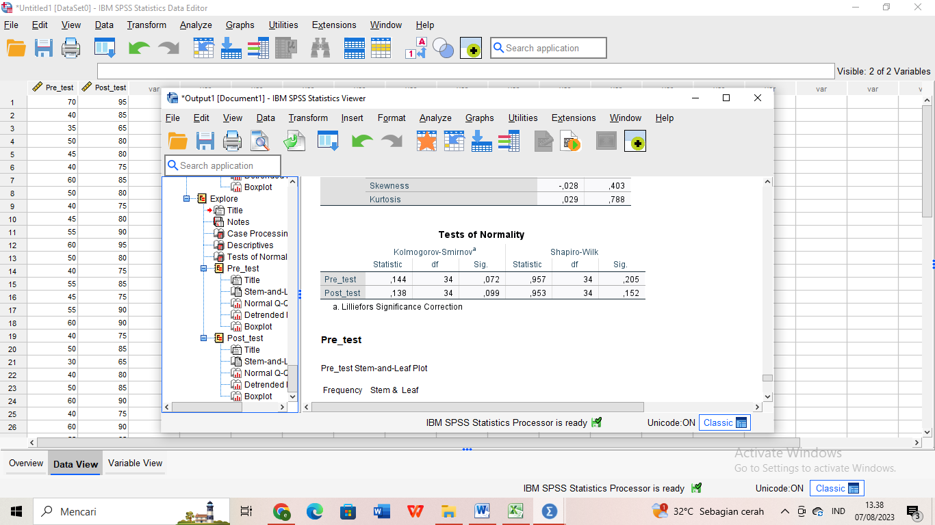
The computation above showed that the significant value (2-tailed) of pre-test was 0.072 and the post-test was 0.099. These two values were higher than 0.05. This was interpreted that both the data in the pre-test and post-test were normally distributed, thus, the next statistical analysis of paired sample test could be taken. Table 3 below displayed the results of paired-sample test analysis:

Table 3 Paired Samples Statistical Analysis
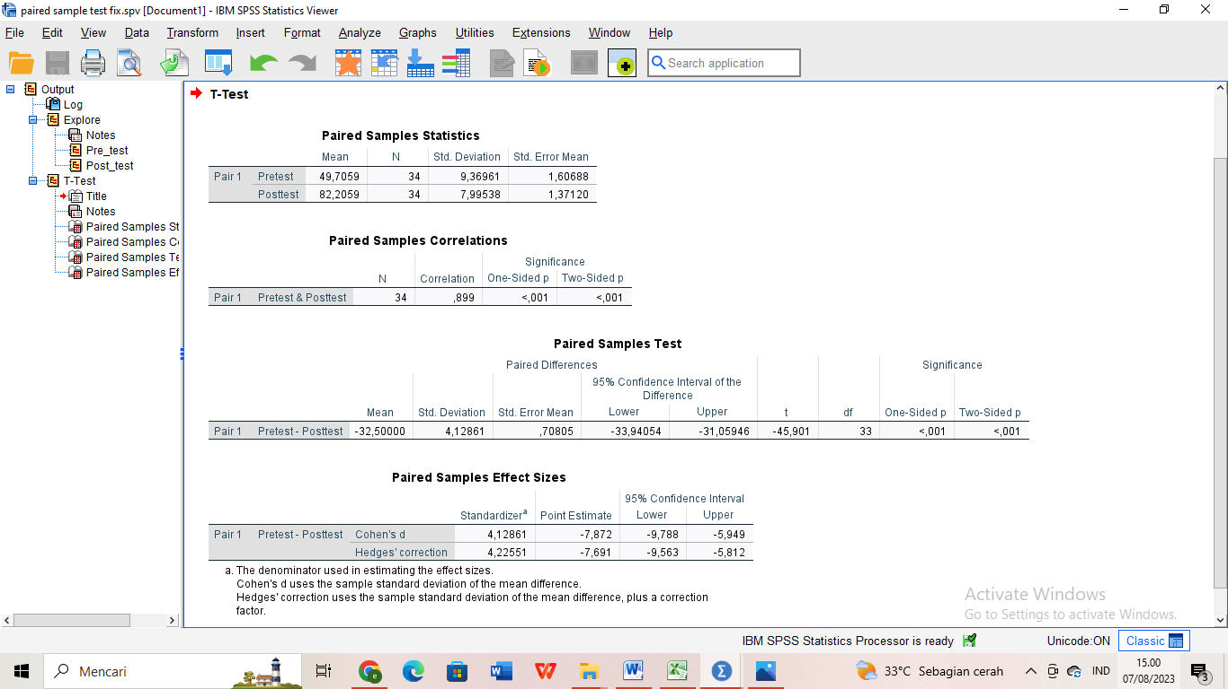
The paired-sample statistical test computation in Table 3 above revealed that the mean score attained by the students in the pre-test resulted standard deviation of 9.369 with standard error mean of 1.606. Meanwhile, the students achieved a mean score of 82.20 in the post-test, with standard deviation of 7.995 and standard error mean of 1.371. Standard deviations of 9.369 (pre-test) and 1.371 (post-test) meant that the data utilised in the pre-test and post-test were both similar. Furthermore, post-test standard error of 1.371 was lower than pre-test standard error of 1.606, meaning that the error made by the students in the post-test was lower than in the pre-test. As a result, it was assumed that students listening comprehension improved significantly after LEDP was used in listening comprehension class.
In order to see the correlation between the two variables; LEDP as variable X and students’ listening comprehension as variable Y, the analysis by using paired-sample correlation was used and the result was presented in Table 5 below:
Table 5 Paired Samples Correlations
Based on the results above in which significance value of 0.001 was less than 0.05. (Sig. 0.01 < 0.05), it was reasonable to conclude that there was a substantial connection between learning with and without the LEDP Application in the process of teaching and learning listening comprehension. Thus, it was concluded that there was an effect of LEDP towards students’ listening comprehension skills.

Conclusion

This experimental research was conducted in the purpose to measure the effectiveness of Listen English Daily Practice (LEDP) application to be utilized in listening comprehension class. The analysis of the data from main sources of pre-test and post-test revealed that after being taught by using this application, the students made improvement in terms of their listening comprehension, this was proven by the average score they reached in the post-test (82.20) which was higher than the one in the pre-test (49.70).

Besides, the statistical analysis of paired-sample test also indicated that the mean score obtained by the students in the pre-test resulted standard deviation of 9.369 with standard error mean of 1.606. Meanwhile, the students achieved a mean score of 82.20 in the post-test, with standard deviation of 7.995 and standard error mean of 1.371. These findings clearly showed that the errors made by the students after they had learnt by using LEDP application were lower compared to prior the treatment.

There was also a correlation between LEDP as variable X and listening comprehension as variable Y in which paired-sample correlations revealed significance value of 0.01 as lower that 0.05 (Sig. 0.01<0.05). This result was meant that there was a substantial correlation between learning with or without LEDP, or in other words, LEDP affected students’ listening comprehension skills.

Referring to the results of data analysis above, this research concluded that Listen English Daily Practice was an effective application utilized in the improvement of students’ listening comprehension skills. Therefore, H₀ was rejected and Ha was accepted.

Due to several drawbacks of this research such as limited sample and variables, the researchers suggest further research which might discuss similar topic to expand this study by involving more sample with various grades. The variables might also be added to get wider research results.

References

Abdulrahman, T. et.al. (2018) The impact of podcasts on EFL students’ listening comprehension, IJOLE: International Journal of Language Education, 2(2), 23-33.

Audina, I.P., et.al. (2022). YouTube video for listening skills during covid-19 pandemic: EFL students’ views. Jurnal Penelitian dan Pengembangan Sains dan Humaniora, 6(3), 327-334. DOI: https://doi.org/10.23887/jppsh.v6i3.55809.
Creswell, J. (2016). Research in education: design, conduct and evaluation of quantitative and qualitative research. Athens: SAGE Publication.

Bano, F. (2017). Towards understanding listening comprehension in EFL classroom: the case of the Saudi learners. English Language Teaching, 10(6), 21-27.

Emilia, V. et.al. (2023). Dailymotion application as teaching media to increase students’ listening skills. TEFL Overseas Journal, 11(1), 92-102.

Frey, B.B. (2018). The SAGE encyclopedia of educational research, measurement, and evaluation. SAGE Publication, Inc.

Gerald, B. (2018). A brief review of independent, dependent and one sample t-test. International Journal of Applied Mathematics and Theoretical Physics, 4(2), 40. DOI: https://doi.org/10.11648/j.ijamtp.20180402.13.
Gilakjani, A.P. & Sabouri, N.B., (2016). The significance of listening comprehension in English language teaching. Theory and Practice in Language Studies, 6(8), 1670-1677. DOI: http://dx.doi.org/10.17507/tpls.0608.22.
Kim, H.S. (2015). Using authentic videos to improve EFL students’ listening comprehension. International Journal of Contents, 11(4), 15-24.
Ningtias, F.P., et.al. (2021). British Council podcast apps to improve students’ listening comprehension. Wiralodra English Journal (WEJ), 5(2), 28-38.
Nurussyifa, N. & Izzah, L. (2022). Application of Listening English Practice in understanding listening for junior high school students. SCRIPTA, 9(2), 158-171.
Purwanto, H.N. (2022). The effect of DuoLingo and SPADA to teach listening to students with different achievement levels. EEJ: English Education Journal, 12(1), 87-95.
Qomariyah, S.S., et.al. (2021). The effect of YouTibe video on students’ listening comprehension performance. Jo-ELT: Journal of English Language Teaching, 8(1), 67-73.
Silvi, N.I. & Nurjati, N. (2023). The effect of using spotify application on EFL listening achievement of senior high school student. SCRIPTA, 10(1), 166-174.
Sondy, T.D., & Mandasari, B. (2021). Teaching English through YouTube video to improve students’ listening comprehension for tenth grade students of SMK Negeri 8 Bandar Lampung. Journal of English Language Teaching and Learning, 4(1), 34-39,
Vahdat, S, & Eidiour, M. (2016). Adopting CALL to improve listening comprehension of Iranian junior high school students. Theory and Practice in Language Studies, 6(8), 1609-1617. DOI: http://dx.doi.org/10.17507/tpls.0608.13.
Vega, O. (2016). Factors to consider when teaching listening comprehension in the EFL/SL classroom. MEXTESOL Journal, 40(4), 1-6.
Yuyun, I. & Simamora, F,Y, (2021) The use of YouTube to support EFL student’s listening skills. ELLTER-J, 2(2), 1-12.

