AN ANALYSIS ON MATERIAL DESIGN OF THE MODULE ENTITLED “BAHASA INGGRIS KELAS 2 SDIT SYAHIRAL ‘ILMI”
Shantya Laila Nasution¹, Merry Prima Dewi, M.Pd²
¹English Education Department, Tarbiyah and Teacher Training Faculty
State Islamic Institute of Bukittinggi, tyalaila14nasution@gmail.com
²State Islamic Institute of Bukittinggi, merryprimadewi@gmail.com

ABSTRACT
This research background was triggered by problems of the module entitled “Bahasa Inggris Kelas 2 SDIT Syahiral 'Ilmi”. The first, English teacher who used the module said that the instructions in the module only use English while students are still in the second grade so students find it difficult to understand what to do with the material. The second, subject materials in the module is quite a lot. The purpose of this research is mainly intended to find out whether the module is appropriate or not with the criteria of good material design suggested by Sundara Rajan.
This research used descriptive quantitative research. In collecting data, the researcher used rubric and documentation as the instrument. The researcher analyzed the module by taking data with the following steps: Finding out the English material, after that identifying the English material, classifying the material, coding data, comparing the English material in the module with the criteria of good material design suggested by Rajan, and provides a percentage to judge the module.
The results showed that the percentage of appropriate on material design for each material in the module includes: Numbers 11-20 is 81,82% or good, Part of Body is 81,82% or good, Simple Instructions 1&2 is 90,91% or good , Thanks and Sorry is 81, 82% or good, Things in The Class is 54,55 or deficient, Part of School is 63,64% or fair, Food is 81,82% or good, Drinks is 81,82% or good, Part of House is 81,82% or good, Things in The Diningroom is 81,82% or good, Things in The Kitchen is 81,82% or good. The final result shows that the percentage of appropriate on the material design developed in the module is 78,51%. It means that the module has good criteria on material design as suggested by Rajan.
Keywords: Analysis, Material Design
ABSTRAK
Latar belakang penelitian ini dipicu oleh permasalahan modul yang berjudul “Bahasa Inggris Kelas 2 SDIT Syahiral 'Ilmi”. Pertama, guru bahasa Inggris yang menggunakan modul mengatakan bahwa petunjuk dalam modul hanya menggunakan bahasa Inggris sementara siswa masih kelas dua sehingga siswa sulit memahami apa yang harus dilakukan dengan materi. Kedua, materi pelajaran dalam modul cukup banyak. Tujuan dari penelitian ini terutama untuk mengetahui apakah modul tersebut sesuai atau tidak dengan kriteria desain material yang baik yang dikemukakan oleh Sundara Rajan.
Penelitian ini menggunakan penelitian deskriptif kuantitatif. Dalam pengumpulan data, peneliti menggunakan rubrik dan dokumentasi sebagai instrumennya. Peneliti menganalisis modul dengan mengambil data dengan langkah-langkah sebagai berikut: Menemukan materi bahasa Inggris, setelah itu mengidentifikasi materi bahasa Inggris, mengklasifikasikan materi, coding data, membandingkan materi bahasa Inggris dalam modul dengan kriteria desain materi yang baik yang disarankan oleh Rajan , dan memberikan persentase untuk menilai modul.
Hasil penelitian menunjukkan bahwa persentase kesesuaian desain materi untuk setiap materi dalam modul meliputi: Angka 11-20 sebesar 81,82% atau baik, Bagian Badan sebesar 81,82% atau baik, Petunjuk Sederhana 1&2 sebesar 90,91% atau baik , Terima kasih dan Maaf adalah 81, 82% atau baik, Hal-hal di Kelas adalah 54,55 atau kurang, Bagian dari Sekolah adalah 63,64% atau sedang, Makanan adalah 81,82% atau baik, Minuman adalah 81,82 % atau baik, Bagian Rumah 81,82% atau baik, Barang di Ruang Makan 81,82% atau baik, Barang di Dapur 81,82% atau baik. Hasil akhir menunjukkan bahwa persentase kesesuaian desain materi yang dikembangkan dalam modul adalah 78,51%. Artinya modul tersebut memiliki kriteria desain material yang baik seperti yang disarankan oleh Rajan.
Kata kunci: Analisis, Desain Material

- INTRODUCTION
Teaching English has developed dramatically in the recent years because globalization impact and everyone should understand English as their International language. The development of English education can also be seen in Indonesia, in which English starts to be taught earlier to young learner. In the past, English was given just to students in junior and senior high school, but now English subject is given from the first up to sixth grade students of elementary school. In Elementary School, English is still taught as a local content. Teaching English in this level is to introduce and socialize English and build English concept.
In teaching English, teacher who teaches in the classroom in carrying out the learning process cannot be separated from books. Therefore, it is very useful for teachers to choose a study book that suits the students' needs. In addition, teacher should look for interesting activities to attract them so that they can acquire English lessons easily. It means that teacher must have learning aid to get them interested in English. Teachers must know about strategies, methods, techniques, and materials.” Thus, the teacher can convey the material well to the students.
Books and learning materials have the power to transmit knowledge, build skills, and shape the way students interact with the world. It means, the book will meet the knowledge, skills, and activities. Books are tools, and teachers must know not only how to use it, but how useful it can be. As a tool, book are expected to be a useful resource in tutoring. The main purpose of book is to transmit knowledge, values, attitudes, skills, and behaviors that are permanent. It is stated that the book is an important learning tool, because all learning abilities have been provided. Thus, it can be said that books are learning resource tools that provide knowledge, skills, values, attitudes, activities, and to motivate students to achieve educational abilities.
Learning materials are important in a teaching and learning process, and are factors that affect the quality of education. With the existence of English books, the roles of teachers and students in the teaching and learning process have changed. Teachers are no longer the main and only source in obtaining information about learning materials, as well as students, they are more flexible and loose in obtaining information about learning materials, because learning materials can be obtained from various sources where students are located, such as from mass media, textbooks, cassettes, CDs, VCDs, and so on.
In the preparation of a good book, several factors are determined, namely the level of difficulty of the subject matter, material that is easy to take precedence over the complex, from the closest environment, the perception of new lessons that are easy to understand if based on knowledge or experience so that there is continuity of learning materials so that they are in accordance with students abilities and along with the interests of students.
English books used in schools usually come from other countries which of course have not been adapted to the language teaching process for foreigners, including Indonesians. This reality allows the selection of materials, sequences and methods of presentation that are suitable for students who have or do not have basic English. In fact, if the material is very good, it is not necessarily appropriate and suitable for Indonesian students. Therefore, the publication of English books for all levels, from elementary, junior high school, senior high school, and university is very much needed.
English book used at SDIT Syahiral 'Ilmi entitled "Bahasa Inggris kelas 2 SDIT Syahiral 'Ilmi" is an English module book used since 2017 until now. This module book was compiled by Team of SDIT Syahiral 'Ilmi'. The photo of school is used as cover. This module book has 71 pages with 11 subject matter for semesters 1 and 2. In each learning material there are basic competencies, standard of competencies, and respective indicators. The materials in this module book are: Number 11-20, Parts of Body, Simple Instructions 1&2, Thanks and Sorry, Things in The Class, Part of School, Food, Drinks, Part of House, Things in The Diningroom, and Things in The Kitchen.
Based on the preliminary research, the researcher found several problems: The first, English teacher who used the module book said that the instructions in the module book only use English while students are still in the second grade so students find it difficult to understand what to do with the material. The module book need to be adapted to the users, because this module book is implemented in schools, so the first target is students. Students have an influence on the development of learning, where each student have different understanding that needs to be considered in the learning process because it affects the goals of education.
The second, the subject matter in the module book is quite a lot. At every change of new subject matter, some students sometimes have difficulty understanding the material because they may not previously have knowledge of the material which causes no continuity of subject matter with students' abilities so that sometimes students are less motivated when learning. On the other hand, the concept of teaching foreign languages ​​contained in learning should not be separated from the concept of learning itself. The better understanding of the nature of student development has given rise to a constructivism view in learning. Regarding language learning, the most important thing to understand is that language learning is an acquisition process with the aim of achieving students' ability to play an active role in the learning process.
From the interview results, the teacher said that in fact the module book still need new inputs to upgrade this module book as well as possible so that it can be used as teaching materials which are much better than the materials that already exist now, so far the module book is quite helpful during teaching and learning activities in the classroom, but of course there are still shortcomings in the module book because nothing is perfect. On the other hand, the students said that learning English is quite difficult because the module have a lot of subject matter. At the first meeting they only learn about a material in module book, pronounce it, and translate the material, then they do the practice in the module book. At the next meeting, they usually repeat the last week's material that has been taught. At the last meeting before moving on to the new material, they did a daily test, and so on. Students also said they was easy to get bored when repeating the material that had been taught previously, especially if the material they did not like or was difficult to understand.
Meanwhile, Rajan stated that good material do not teach but good material can motivate a learner to learn. The criteria for a good material design based on Rajan are like MAGIC. The meaning of MAGIC is as follows: Motivating, Meaningful, Authentic, Appropriate, Graphic, Graded, Interesting, Integrated, Interactive, Contextualized and Creative.
Based on the problems above, the researcher interested in analyzing the material in the module book for the second grade of SDIT Syahiral 'Ilmi with the criteria of good material based on Rajan's Theory, whether the module book is appropriate with Rajan's criteria or not. Based on that reasons, the researcher decided to conduct a research entitled “An Analysis on Material Design of The Modul entitled “Bahasa Inggris Kelas 2 SDIT Syahiral ‘Ilmi”.

- RESEARCH METHOD
The background of this research was descriptive quantitative. The researcher wants to know and describe the appropriate on material design of the module entitled “Bahasa Inggris kelas 2 SDIT Syahiral ‘Ilmi” with good material design criteria suggested by Rajan. According to Lehman state that descriptive quantitative research was a type of research that aims to describe systematically, factually, and accurately the fact and characteristics of a particular population, or to try to describe phenomena in detail. The objective of descriptive research was to systematically describe the facts and characteristics of a given population or area of interest.
In this study, the researcher have described the appropriate on the material design of the module entitled “Bahasa Inggris kelas 2 SDIT Syahiral ‘Ilmi” with the criteria of good materials suggested by Rajan. There was data on documents related to theory. Researchers was analyze the data and try to interpret the data. Finally, there was more detailed explanation of whether the material of the module entitled “Bahasa Inggris kelas 2 SDIT Syahiral ‘Ilmi” appropriate with the criteria of good material design suggested by Rajan and an explanation of what the teacher should consider if she wants to use this module in the classroom. All of these explanations was presented using words or linguistics or language from sources in the research setting.
Instrument was a tool used to collect data. Suharsimi in Sudaryono, Margono, and Rahayu said that instrumentation is a tool chosen and used by researchers in their activities to collect data so that research becomes systematic and simple. The researcher made an instrument in the form of a rubric using Rajan's theory. The rubric that used as an instrument in this research was validated by 3 validators. After being validated by the validator, then the instrument was used to analyze this textbook according to Rajan's theory. The instrument used in this research was documentation. Sugiyono says that documentation is a record of events that have passed. The document can be in the form of writing, pictures, or someone's monumental work. In addition, Arikunto in Azizah and Purwoko also explains that documentation is a collection of data about such as notes, transcripts, books, newspapers, magazines, etc. In this study, researchers use note, book, and journals about material related to analysis on material design of the module based on Rajan's theory.
Data analysis is one of the activities in research that is useful for drawing conclusions. The researcher analyzed the module by taking several steps, such as: Finding out the English material provided of the module, after that identifying the English material, classifying the material, coding data, comparing the English material of the module with the criteria of good material design suggested by Rajan, and the last one provides a percentage to judge whether the module is appropriate with the criteria of good material suggested by Rajan or not.
The researcher gives percentages to analyzed the module entitled “Bahasa inggris Kelas 2 SDIT Syahiral ‘Ilmi” whether good or not based on criteria suggested by Rajan. The researcher uses the theory from Walizer edited by Sadiman. The researcher also was classified data by Suharsimi Arikunto to percentages it.
The formula is : Percentage = $\frac{Amount of Rajan^{'}s criteria in material}{Total Rajan^{'}s criteria}$ X 100%
The percentages are : 76% -100% = Good, 56% -75% = Fair, 40% -55% = Deficient, < 40% = Not good.

- FINDINGS AND DISCUSSION
In analyzing the research, the researcher analyzes the appropriate on the material design of the module entitled "Bahasa Inggris Kelas 2 SDIT Syahiral 'Ilmi" with criteria of good material design suggested by Rajan. The researcher has several findings which are described below.
- FINDINGS
Description of The Data
The data in this research were collected from the module entitled “Bahasa Inggris Kelas 2 SDIT Syahiral ‘Ilmi” for further analyzed. The final result of the data served as numerical data because the kind of this research is descriptive quantitative.
The data were in the form of a rubric in analyzing module with the answer choices Yes or No by the researcher and English teachers as Raters. In filling out the rubric, the researcher gave an explanation and time for English teachers to answer by checking the answer in the Yes or No column based on the statements in the rubric adapted to the content on the material design of the module. So, the researchers found an overview of the appropriate on material design of the module with criteria of good material design suggested by Rajan.
The items of the answered statements were then calculated into a table to find out the description and percentage of appropriate on material design of the module entitled “Bahasa Inggris Kelas 2 SDIT Syahiral ‘Ilmi” with the criteria of good material design suggested by Rajan. The researcher uses the theory from Walizer which was edited by Sadiman. The researcher also classified the data by Suharsimi Arikunto into percentages of the module. A more detailed description could be seen below.
Based on research questions about the appropriate on material design of the module entitled “Bahasa Inggris Kelas 2 SDIT Syahiral ‘Ilmi” with criteria of good material design suggested by Rajan, the researcher will describe with a general explanation. In the criteria of good materials design suggested by Rajan, there are eleven criteria, namely motivating, meaningful, authentic, appropriate, graphic, graded, interesting, integrated, interactive, contextual, and creative. The materials in the textbook are Number 11-20, Parts of Body, Simple Instructions 1&2, Thanks and Sorry, Things in The Class, Part of School, Food, Drinks, Part of House, Things in The Diningroom, and Things in The Kitchen. In each of material was presented in the form of a percentage based on the rater's answer.

The Table of Percentages
Table 4.1
No | Material | Rajan’s Criteria | CDT | CDSR | Percentage | Quality
1 | Number 11-20 | Motivating Meaningful  Authentic  Appropriate  Graphic  Graded  Interesting  Integrated  Interactive  Contextual  Creative | 9 | 11 | $\frac{9}{11}$ x 100% = 81,82% | Good
2 | Parts of Body |  | 9 | 11 | $\frac{9}{11}$ x 100% = 81,82% | Good
3 | Simple Instructions 1&2 |  | 10 | 11 | $\frac{10}{11}$ x 100% = 90.91% | Good
4 | Thanks and Sorry |  | 9 | 11 | $\frac{9}{11}$ x 100% = 81,82% | Good
5 | Things in The Class |  | 6 | 11 | $\frac{6}{11}$ x 100% = 54,55% | Deficient
6 | Part of School |  | 7 | 11 | $\frac{7}{11}$ x 100% = 63,64% | Fair
7 | Food |  | 9 | 11 | $\frac{9}{11}$ x 100% = 81,82% | Good
8 | Drinks |  | 9 | 11 | $\frac{9}{11}$ x 100% = 81,82% | Good
9 | Part of House |  | 9 | 11 | $\frac{9}{11}$ x 100% = 81,82% | Good
10 | Things in The Diningroom |  | 9 | 11 | $\frac{9}{11}$ x 100% = 81,82% | Good
11 | Things in The Kitchen |  | 9 | 11 | $\frac{9}{11}$ x 100% = 81,82% | Good
TOTAL |  |  | 95 | 121 | $\frac{95}{121}$ x100% = 78,51% | Good
Note : The data is adjusted to the results of the analysis.
CDT : Criteria Development in the module entitled “Bahasa Inggris Kelas 2 SDIT Syahiral Ilmi”
CDSR : Criteria Demanden by Sundara Rajan
The Formula is : Percentage = $\frac{Amount of Rajan^{'}s criteria in material}{Total Rajan^{'}s criteria}$ X 100%
The percentages are : (76% - 100% = Good, 56% - 75% = Fair, 40% - 55% = Deficient, < 40% = Not good).
The percentage of these criteria of the module entitled "Bahasa Inggris Kelas 2 SDIT Syahiral 'Ilmi" is 78,51%. It means that the material of the module is good and compatible with the criteria of good materials design suggested by Rajan.
Analysis of The Data
In the findings of the research, the researcher outlines several points to determine the appropriate on material design of the module. The data were analyzed based on eleven criteria of good material design suggested by Rajan. The criteria of good material design based on Rajan are like MAGIC. The meaning of MAGIC is as follows: Motivating, Meaningful, Authentic, Appropriate, Graphic, Graded, Interesting, Integrated, Interactive, Contextualized and Creative. The data was collected from the module entitled “Bahasa Inggris Kelas 2 SDIT Syahiral ‘Ilmi”. The explanation of these criteria are explained below:

- M = Motivating and Meaningful
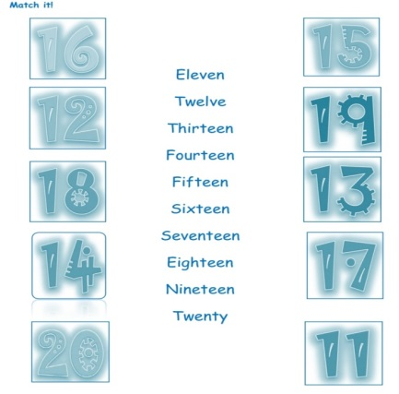
Picture 4.1
The material above is appropriate with the criteria of good material design suggested by Rajan. The material is according to the interests of students and it is presented with pictures so that students are motivated to learn or answer questions. The material above asks students to match vocabulary with pictures. Then students are asked to draw arrows that connect the word with the appropriate object. From 11 subject matter, the motivating criteria are contained in all materials, namely Number 11-20, Parts of Body, Simple Instructions 1&2, Thanks and Sorry, Things in The Class, Part of School, Food, Drinks, Part of House, Things in The Diningroom, and Things in The Kitchen.
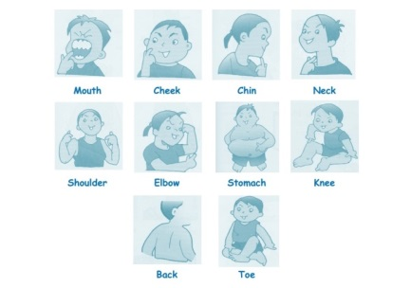
Picture 4.2
The material above is appropriate with the criteria of good material design suggested by Rajan. The material is presented with pictures to make it easier for students to understand vocabulary. The material is very useful for students because it can improve student learning abilities. From 11 subject matter, the meaningful criteria are contained in all materials, namely Number 11-20, Parts of Body, Simple Instructions 1&2, Thanks and Sorry, Things in The Class, Part of School, Food, Drinks, Part of House, Things in The Diningroom, and Things in The Kitchen.
- A = Authentic and Appropriate
From 11 subject matter, the authentic criteria are not contained in all materials. The material does not contain native language by native speakers or there are no tapes / recordings in each chapter about the vocabulary.
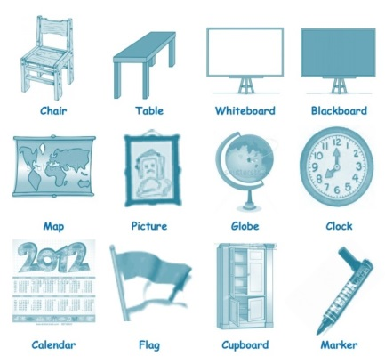
Picture 4.3
The material above is appropriate with the criteria of good material design suggested by Rajan. The material is adapted to the background / needs of the learners and it is presented with pictures in the form of objects in daily life so that students will find it easier to learn. From 11 subject matter, the appropriate criteria are contained in all materials, namely Number 11-20, Parts of Body, Simple Instructions 1&2, Thanks and Sorry, Things in The Class, Part of School, Food, Drinks, Part of House, Things in The Diningroom, and Things in The Kitchen.
- G = Graphic and Graded
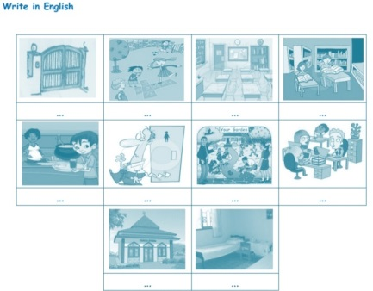
Picture 4.4
The material above is appropriate with the criteria of good material design suggested by Rajan. The material is presented in the form of a table in which there are pictures so that it is easy to learn and make students better understand the learning material and more interested in filling out answers. The material above asks students to write down vocabulary in a table according to the picture. From 11 subject matter, the graphic criteria are contained in all materials, namely Number 11-20, Parts of Body, Simple Instructions 1&2, Thanks and Sorry, Things in The Class, Part of School, Food, Drinks, Part of House, Things in The Diningroom, and Things in The Kitchen.
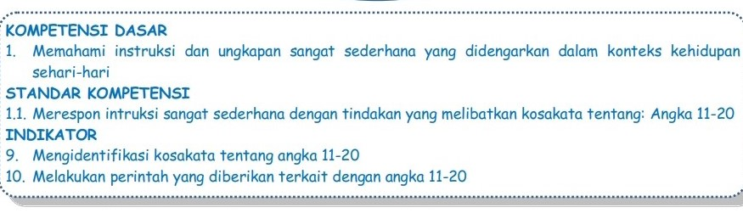
Picture 4.5
The material above is appropriate with the criteria of good material design suggested by Rajan. The material is arranged systematically. The structure of the material in the textbook is in accordance with the learning stages recommended by the curriculum. There are basic competencies, standard of competencies, and their respective indicators. From 11 subject matter, the graded criteria are contained in all materials, namely Number 11-20, Parts of Body, Simple Instructions 1&2, Thanks and Sorry, Things in The Class, Part of School, Food, Drinks, Part of House, Things in The Diningroom, and Things in The Kitchen.
- I = Interesting, Integrated, and Interactive
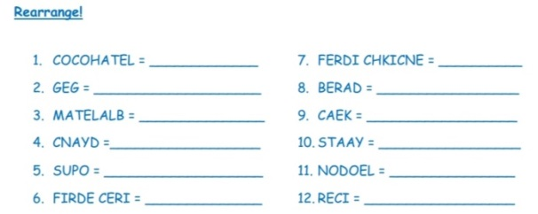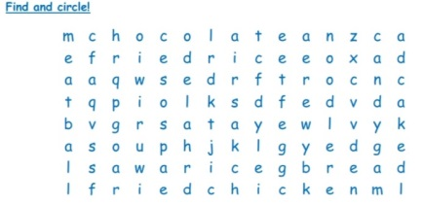
Picture 4.6
The material above is appropriate with the criteria of good material design suggested by Rajan. The material is presented in the form of pictures that attract students' interest so that students feel interested in answering questions and it can provide opportunities for students to think actively. In this material there are vocabulary in the form of random letters. Students are asked to rearrange the letters into the correct vocabulary and there are also students who are asked to find and circle the correct vocabulary. From 11 subject matter, the interesting criteria are contained in 9 subject materials, namely Number 11-20, Parts of Body, Simple Instructions 1&2, Thanks and Sorry, Food, Drinks, Part of House, Things in The Diningroom, and Things in The Kitchen.

LISTENING
Intruction: Listen and Checklist!
SPEAKING
Intruction: Read it!
READING
Intruction: Read it!
Intruction: Match it!
Intruction: Find and Circle!
WRITING
Intruction: Write it!
Intruction: Fill the missing letter!
Intruction: Crossword
Intruction: Rearrange the jumble words!
Picture 4.7
The material above is appropriate with the criteria of good material design suggested by Rajan. The material in accordance with the principles of learning English contains four language skills, namely Listening, Speaking, Reading, and Writing. From 11 subject matter, the integrated criteria are contained in all materials, namely Number 11-20, Parts of Body, Simple Instructions 1&2, Thanks and Sorry, Things in The Class, Part of School, Food, Drinks, Part of House, Things in The Diningroom, and Things in The Kitchen.
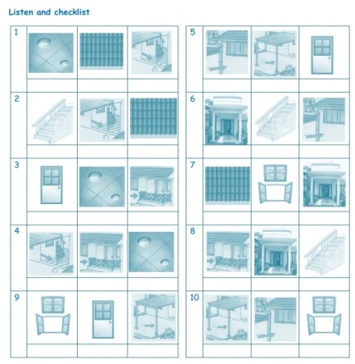
Picture 4.8
The material above is appropriate with the criteria of good material design suggested by Rajan. The material is designed in an interactive form so that it can provide opportunities for students to respond. In this material the teacher gives instructions to students, namely listen and checklists. The teacher recites one of the vocabularies from the three pictures in the table, after the students listen to what the teacher says then the students give answers to the instructions by marking it in the form of a checklist for one correct answer. From 11 subject matter, the interactive criteria are contained in 9 subject materials, namely Number 11-20, Parts of Body, Simple Instructions 1&2, Part of School, Food, Drinks, Part of House, Things in The Diningroom, and Things in The Kitchen.
- C = Contextualized and Creative
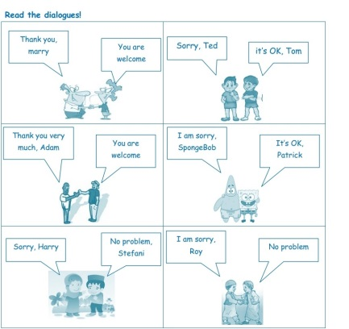
Picture 4.9
The material is appropriate with the criteria of good material design suggested by Rajan. The material above is in accordance with the activities of students. The materials are about conversations in the form of dialogue, the sentences are simple and easy to understand. This is a daily activity for students, so students can follow dialogue, they can practice it. From 11 subject matter, the contextualized criteria are contained in 2 subject materials, namely Simple Instructions 1&2, Thanks and Sorry.
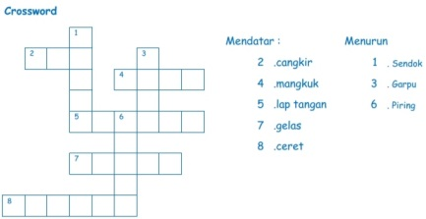
Picture 4.10
The material above is appropriate with the criteria of good material design suggested by Rajan. The material can create students' creativity in learning English because students can answer these questions while learning and playing. The material above is presented in the form of a crossword. Students are asked to fill in the vocabulary in the horizontal column and descending column according to the instructions. From 11 subject matter, the creative criteria are contained in 9 subject materials, namely Number 11-20, Parts of Body, Simple Instructions 1&2, Thanks and Sorry, Food, Drinks, Part of House, Things in The Diningroom, and Things in The Kitchen.
The researcher concluded that based on the results of the research, after analyzing the material in the module entitled "Bahasa Inggris Kelas 2 SDIT Syahiral 'Ilmi" with eleven criteria of good material design suggested by Rajan. The researcher found that there were ten (10) criteria out of eleven (11) criteria that were compatible with the material in the textbook. It means that the material in the module is good and compatible with the criteria of good material design suggested by Rajan.
- DISCUSSION
This section presents a discussion based on the research findings. Several things can be noted related to the analysis on material design of the module entitled “Bahasa Inggris Kelas 2 SDIT Syahiral ‘Ilmi”.
Based on the criteria of good material design suggested by Rajan, there are eleven criteria, namely: Motivating, Meaningful, Authentic, Appropriate, Graphic, Graded, Interesting, Integrated, Interactive, Contextualized and Creative. Based on research findings, after analyzing the material in the module, the researcher found ten (10) criteria from eleven (11) criteria which are compatible with the materials in the textbook. In some cases, researcher found the same criteria contained in 11 subject matter in the module. The final result shows that the percentage of appropriate on material design of the module is 78,51% (Table 4.1). It can be concluded that the module has good criteria of material design as suggested by Rajan.
Based on the explanation about the criteria of good material, Hutchinson and Waters put forward several ideas about good materials such as; (i) good material does not teach, it encourages learners to learn; (ii) good material will contain interesting texts, fun activities that involve students' thinking skills, opportunities for students to use existing knowledge and skills, and content that can be overcome by students and teachers; and (iii) good material should provide a clear and coherent unit structure that will guide teachers and students through various activities in such a way as to maximize learning opportunities. Based on the research findings in the module entitled “Bahasa Inggris Kelas 2 SDIT Syahiral 'Ilmi” Researchers found that this module contains most of the criteria items as mentioned by the theory. So, the findings in this research are in accordance with the theory.
Based on the explanation about component of module, according to Prastow, the module should include six components. They are; 1) the explicit formulation of teaching objectives, 2) student worksheets, 3) answer key sheets, 4) evaluation sheets, 5) evaluation answer sheets, and 6) teacher guidelines. Based on the research findings, the module entitled “Bahasa Inggris Kelas 2 SDIT Syahiral 'Ilmi” only has one component as stated in the theory. Thus, the findings in this research are not in accordance with the theory.

- CONCLUSION
After analysis on material design of the module entitled "Bahasa Inggris Kelas 2 SDIT Syahiral 'Ilmi" compiled by the SDIT Syahiral 'Ilmi Team, the researcher can make conclusions from the results of the research as follows:
Based on the criteria of good material design suggested by Rajan, the researcher states that the module entitled "Bahasa Inggris Kelas 2 SDIT Syahiral 'Ilmi" compiled by the SDIT Syahiral 'Ilmi Team have a good material design as suggested by Rajan. It has been proven in the analysis of this research that the appropriate on material design of the module is 78,51% (Table 4.1). The researcher found that each material contains an average of nine criteria, maximum of ten and minimum of six from the eleven criteria that exist were appropriate with the material in the module.

REFERENCES
Amrina, 2018.“An Analysis Of “Bahasa Inggris” Textbook Used in the Second Grade of Senior High School”.
Arikunto, Suharsimi. 1998. Prosedur Penelitian: Suatu Pendekatan Praktek. Jakarta: Rinneka Cipta.
Azizah, A. & Purwoko, B. Studi Kepustakaan Mengenai Landasan Teori dan Praktik Konseling Naratif. (Jurnal BK UNESA Vol. 7, No. 2, 2017).
Education Sector. 2005. A Comprehensive strategy for textbooks and learning materials. France: the united nations scientific and cultural education.
Harmer, Jeremy. 2001. The Practice of English Language Teaching. Third edition. Longman Pearson Education Limited.
Hutchinson, Tom and Waters, Alan. (1987). English for Specific Purpose: A Learning Centered Approach, Cambridge: Cambridge University Press.
Prastowo, A. (2014), Pengembangan Bahan Ajar Tematik: Tinjauan Teoritis dan Praktik, (Jakarta: Kencana Prenadamedia Group.
Rajan, Sundara. 2003. Material Design. SEAMO. Regional Language Centre.
S. Nasution. 2009. Asas-asas Kurikulum. Jakarta: Bumi Aksara.
Sari, Anisa Novita, 2019. “An Analysis of Textbook Entitled “Headline English” Published by Srikandi Empat of Seventh Grade of Junior High School”.
Setiawan, 2019. “Content Analysis of English Textbooks for Senior High School Entitled “Pathway to English” Based On Curriculum 2013, University of Muhammadiyah Malang”.
Sudaryono, Gaguk Margono, & Wardani Rahayu. (2013), Pengembangan Instrumen Penelitian Pendidikan, Yogyakarta: Graha Ilmu.
Sugiyono, 2010. Metodologi Penelitian Kuantitatif Kualitatif dan R&D, Bandung: Alfa Beta Bandung.
Walizer, edited by Sadiman. 1991. Metode dan Analisis Penelitian: Mencari Hubungan. Jakarta: Penerbit Erlangga.
Williams, David. 1983. Developing Criteria for Textbook Evaluation. ELT Journal Volume 37/3 July.
Yusuf, Muri. (2014). Metode Penelitian. Jakarta: Kencana

Jeremy Harmer, The Practice of English Language Teaching Third edition, (Longman: Pearson Education Limited, 2001).
Education Sector, A Comprehensive Strategy for Textbooks and Learning Materials, France: The United Nation Scientific ang Cultural Education, (2005).
David Williams, Developing Criteria for Textbook Evaluation, ELT Journal Volume 37/3 July (1983), p. 254
Education Sector, Op.Cit
S. Nasution, Asas-asas Kurikulum, (Jakarta: Bumi Aksara, 2009), p.246
Sundara Rajan, Material Design, SEAMO. Regional Language Centre, (2003).
Muri Yusuf, Metode Penelitian, (Jakarta: Kencana, 2014), p.62
Sudaryono, Gaguk Margono, & Wardani Rahayu, Pengembangan Instrumen Penelitian Pendidikan, (Yogyakarta: Graha Ilmu, 2013), p.30
Sugiyono, Metodologi Penelitian Kuantitatif Kualitatif dan R&D, (Bandung: Alfa Beta Bandung, 2010), p.329
Ainul Azizah & Budi Purwoko, Studi Kepustakaan Mengenal Landasan Teori dan Praktik Konseling Naratif, (Jurnal BK UNESA Vol.7, No.2, 2017), p.3
Walizer, edited by Sadiman, Metode dan Analisis Penelitian: Mencari Hubungan. (Jakarta: Penerbit Erlangga, 1991)
Suharsimi Arikunto, Prosedur Penelitian: Suatu Pendekatan Praktek. ) Jakarta: Rinneka Cipta, 1998).
Walizer, edited by Sadiman, Metode dan Analisis Penelitian: Mencari Hubungan. (Jakarta: Penerbit Erlangga, 1991)
Suharsimi Arikunto, Prosedur Penelitian: Suatu Pendekatan Praktek. )Jakarta: Rinneka Cipta, 1998).
Sundara Rajan, Material Design, SEAMO. Regional Language Centre, (2003).
Sundara Rajan, Materisl Design, SEAMO. Regional Language Centre, (2003).
Tom Hutchinson and Alan Waters, English for Specific Purpose: A Learning Centered Approach, (Cambridge: Cambridge University Press, 1987), p.107
Prastowo, Pengembangan Bahan Ajar Tematik: Tinjauan Teoritis dan Praktik, (Jakarta: Kencana Prenadamedia Group, 2014).

