ARTICLE WRITING GUIDELINES
EDUCATIVE JOURNAL : Journal of Education Studies

Parental Social Support as a Predictor of Student Career Adaptability
Alfi Rahmi
BK FTIK UIN Bukittinggi, Indonesia
BK UNP Doctoral Program, Indonesia
alfirahmi@iainbukittinggi.ac.id

Firman, Afdal
BK FIP UNP, Indonesia
firman@konselor.org, afdal@konselor.org

©2020 by the authors. Submitted for possible open access publication under the terms and conditions
of the Creative Commons Attribution (CC-BY-SA) license (https://creativecommons.org/licenses/by-sa/4.0/)
DOI : http://dx.doi.org/10.30983/educative.v5i1

Received: date, month, year | Revised: date, month, year | Published:date month year

Abstract( Garamond 1 2 , Bold, space 1, spacing before 12 pt, after 2 pt)
Keterampilan dan wawasan diperlukan untuk mempersiapkan transisi dari universitas ke dunia kerja. Salah satu sumber kesiapan memasuki dunia kerja adalah dukungan sosial. Pendukung sosial utama dalam mempersiapkan diri memasuki dunia kerja adalah orang tua atau keluarga. Salah satu faktor eksternal yang juga mendukung pilihan karir pada siswa adalah dukungan sosial dari orang tua. Penelitian ini bertujuan untuk mendeskripsikan bentuk dukungan sosial yang diterima siswa dari orang tuanya sebagai bentuk dukungan sosial dalam memilih karir masa depan siswa. Jenis penelitian ini adalah deskriptif kuantitatif dengan teknik analisis data persentase. Populasinya adalah siswa BK tingkat akhir yang berjumlah 95 orang dengan teknik total sampling. Hasil penelitian membuktikan bahwa data dukungan emosional memiliki skor rata-rata 20,47, data dukungan reward memiliki skor rata-rata 20,21, data dukungan instrumental memiliki skor rata-rata 19,96, dukungan informasi memiliki skor rata-rata 18,98, dukungan jejaring sosial dengan skor rata-rata 15,26. Berdasarkan hasil penelitian tergambar bahwa dukungan sosial yang paling tinggi adalah dukungan emosional.
Kata kunci: dukungan sosial, orang tua, adaptabilitas karir
Abstract
Skills and insights are needed to prepare for the transition from university to the world of work. One source of readiness to enter the world of work is social support. The main social support in preparing to enter the world of work is parents or family. One of the external factors that also supports career choice in students is social support from parents. This study aims to describe the form of social support received by students from their parents as a form of social support in choosing a student's future career. This type of research is descriptive quantitative with percentage data analysis techniques. The population is final-year BK students, totaling 95 people with a total sampling technique. The results of the study prove that emotional support data has an average score of 20.47, reward support data has an average score of 20.21, instrumental support data has an average score of 19.96, informational support has an average score of 18.98, social network support with an average score of 15.26. Based on the research results, it is illustrated that the highest social support is emotional support.

Keywords: social support, parents, career adaptability

Background
In the era of society 5.0, which is more dominant, humans must be prepared to face an increasingly fast era and have the skills to keep up with the acceleration of this technology. Skill weaknesses will certainly have an impact in the post-college world with more and more unemployed. Based on data from the Central Statistics Agency (BPS) shows that the number of unemployed in Indonesia in February 2022 was 8.40 million people https://www.bps.go.id/indicator/6/1953/1/nomor-dan-persentase-penduduk-bekerja-dan-penggiran.html
This is a very drastic amount, of course, we will not choose to be one that will increase the number of unemployed people.
A large number of unemployed come from universities because of new graduates who do not yet have skills that are in line with the needs of the field, while graduates have expectations of higher income and status. There is a phenomenon that many college graduates are not absorbed in the world of work, which requires a change in the pattern of providing education so as to improve the response to the various challenges that exist. Attitudes less responsive to changes in the surrounding environment caused by the contents of the higher education curriculum are still scientifically oriented.
.
To support the suitability between the fields of knowledge and the career fields undertaken in the world of work, readiness to enter the world of work is required. Final year students of the Guidance and Counseling Study Program FTIK UIN Bukittinggi in 2022 obtained data on the level of readiness to enter the world of work as many as 33.33% of students were in a fairly good position, with sub-indicators on aspects of ability 38.01%, aspects of willingness 39.15% and aspects of self-confidence 39.51% .
It is an important factor for students to prepare the abilities and insights needed for their careers in preparation for the transition from university to the world of work .
Sources of readiness to enter the world of work include social support. Social support is a significant predictor in the development of future career adaptability . One of the main social supports in choosing this career is parents or family.
.
Social support affects career adaptability in young adulthood in choosing a career later. This is because individuals will feel that they are getting social support in the form of emotional support from various sources that will be useful for individuals who will plan and explore their careers . Weisenberg and Aghakhani explain that the sources of social support for young adults are schools (institutions), family, and friends.

Social support from parents will help prospective graduates prepare themselves to enter the world of work. The source of student readiness to face various obstacles in the transition period to enter the world of work is career adaptability . . Career Adaptability is an individual's ability to prepare and complete a variety of predictable tasks and be involved in various roles in work and have the ability to overcome unexpected problems that will occur in the work and working conditions undertaken

Through this research, it will be described the level of social support obtained by final-year students of the Guidance and Counseling Study Program in obtaining social support. Good social support will help prepare them to enter the world of work.

Research methods
This study uses a quantitative descriptive that describes the form of social support received by students in choosing a career.
The research subjects were final-year students of the guidance and counseling study program. These final-year students are currently undergoing the process of thesis guidance and Guidance and Counseling Field Practice in Schools with a total sample of 95 people..
Data collection is done by using google Forms. The scale used is the Social Support Scale which contains 5 aspects, namely social support, emotional support, appreciation social support and instrumental social support, information support, and social network support. The social support scale uses a Likert scale.
Data analysis techniques using the percentage formula
𝑃 = 100%
N
Information:
P = Percentage
F = number of responses from respondents
N = number of respondents

The results of parental social support criteria will then be analyzed using the following
Table:1: Criteria for Parental Social Support in Career Selection
No | Criteria | intervals
1 | Very high | 85%-100%
2 | Tall | 69 % - 84%
3 | Enough | 53 %- 68%
4 | Low | 36 %- 52%
5 | Very low | 0 – 35%

Results and Discussion
- Description of Research Subjects
The number of respondents from this study was 95 final-year Guidance and Counseling Study Program Students. The results of the distribution of respondent data will be classified as follows:
Results of the First Research Regarding the Occupation of Parents of Research Subjects. The results of the first study describe the research subject data including:
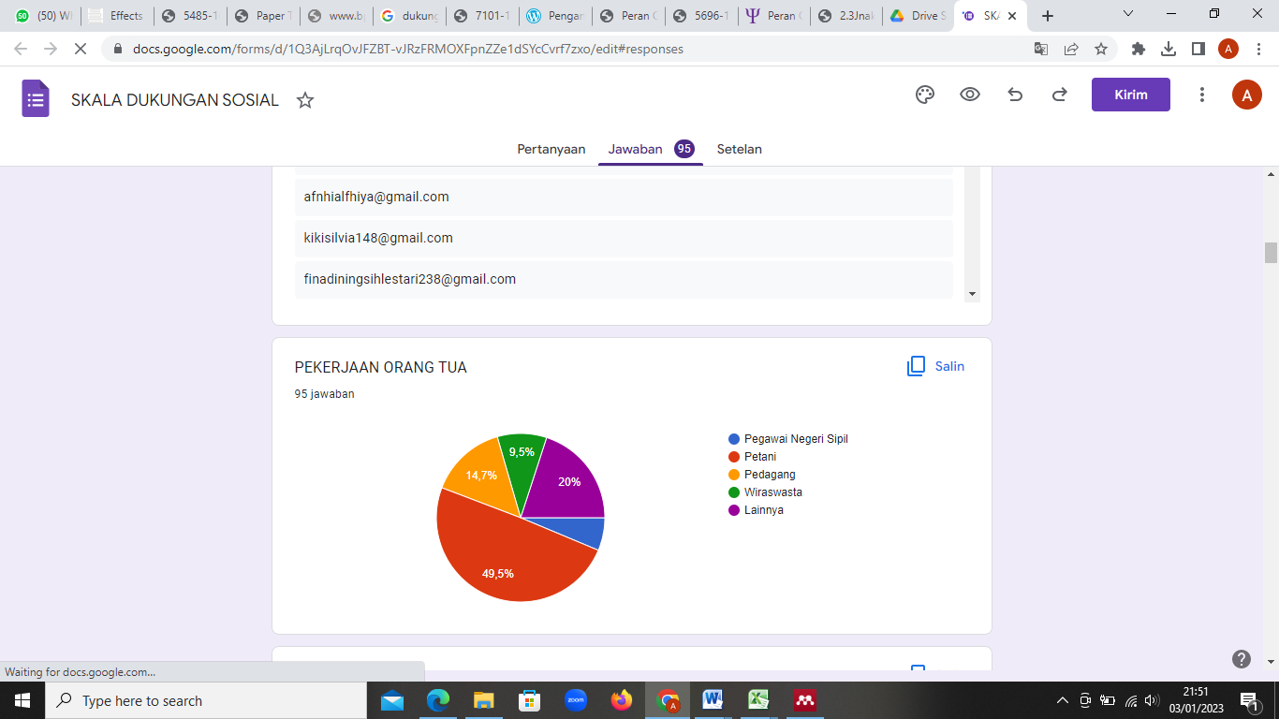

Based on the data above it is described that:
- Civil Servants 6.3%
- Farmers 49.5%
- Merchants 14.7%
- Entrepreneur 9.5%
- Others 20%

Based on the data, it is known that in general the occupations of the parents of Final Year students of the Guidance and Counseling Study Program are Farmers (49.5%) and the least number are Civil Servants (6.3%).
The results of the second study describe the level of parental education
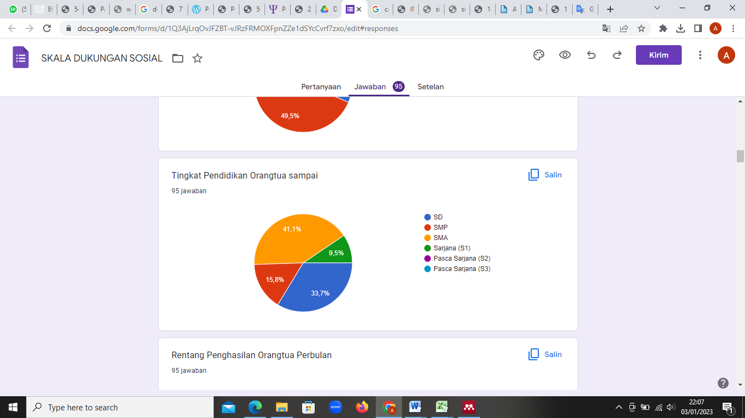

Based on the graph above, it can be described the level of education of the parents of the research subjects, namely:
- SD 33.7%
- Junior High School 15.8%
- SMA 41.1%
- Undergraduate 9.5%
Based on the graphic data above, it is illustrated that as many as 41.1% of parents of students with high school education level.
The results of the third study describe the range of parents' monthly income
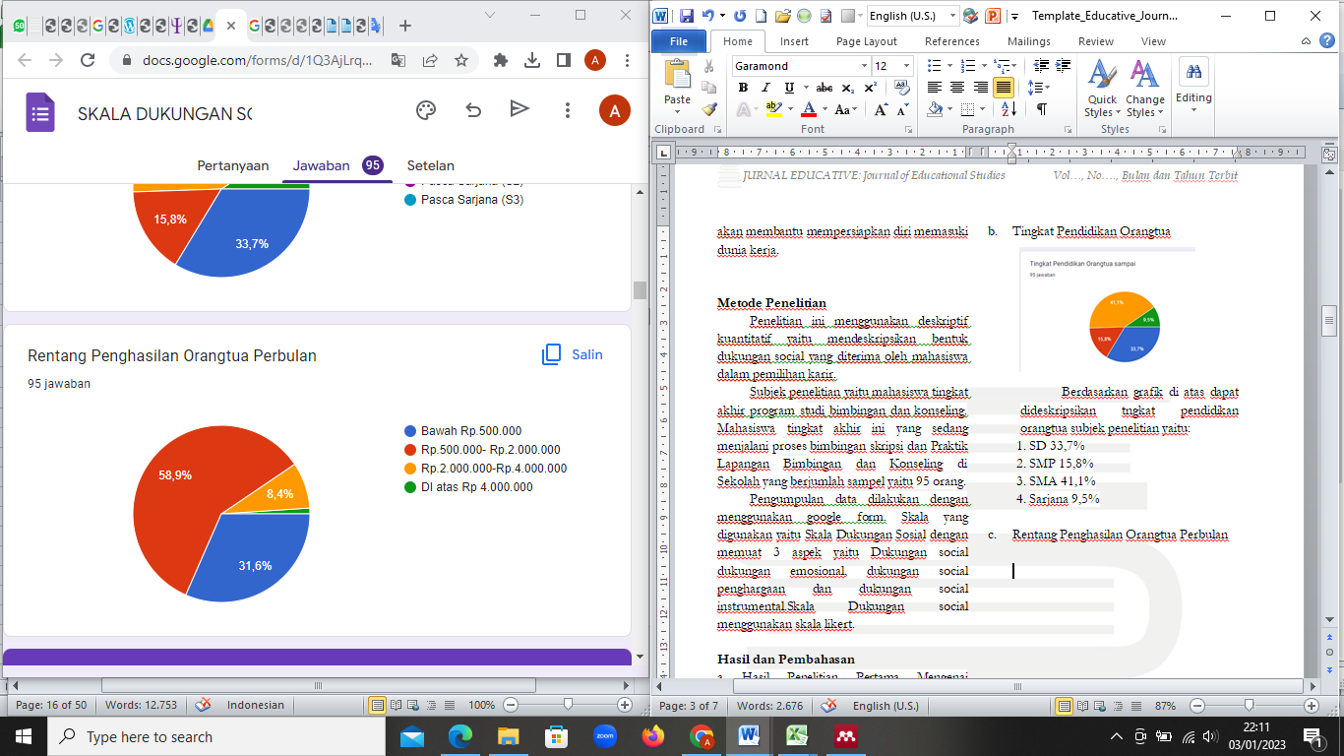

Based on the graphic data above, it can be described that the parental income range is:
- Under IDR 500,000 amounted to 31.6%
- Range Rp. 500,000-Rp. 2,000,000 amounted to 58.9%
- Range Rp. 2,000,000-Rp.4,000,000 amounting to 8.4%
- Range above IDR 4,000,000 amounts to 1.1 %
Based on research data, it is described that the average parental income is 58.9%

Research Data on Parental Social Support in Career Selection. The forms of social support according to Sarafino (2011) are as follows: (1) Appreciation support, this support can be in the form of positive appreciation to others, encouraging and giving approval of individual ideas or feelings, giving encouragement, and comparing the person positively; (2) Emotional support, namely support related to
There is some social support provided by parents to students, namely Emotional social support, Awards, Instrumental, Information, and Social Networking.
.
The following is an overview of the overall results of the form of social support provided by parents to students.

Table 2: Social Support From Parents
No | Criteria | intervals | Frequency
1 | Very high | 85%-100% | 12
2 | Tall | 69 % - 84% | 65
3 | Enough | 53 %- 68% | 13
4 | Low | 36 %- 52% | 5
5 | Very low | 0 – 35%

Based on the data above, it can be illustrated that the social support obtained by 12 students is in the Very High category, 65 people are in the High category, 13 people are in the sufficient category, and 5 people are in a low category.

Descriptive Statistics
 | N | Minimum | Maximum | Means | std. Deviation
Emotional Support | 95 | 7 | 25 | 20.47 | 3,943
Award Support | 95 | 10 | 25 | 20.21 | 3,803
Instrumental Support | 95 | 7 | 25 | 19.96 | 4,538
Information Support | 95 | 5 | 25 | 18.98 | 4,458
Social Network Support | 95 | 8 | 20 | 15.26 | 2,519
Valid N (listwise) | 95

Based on the above data the average score of emotional support is 20.47, appreciation support is 20.21, instrumental support is 19.96, information support is 18.98, and social network support is 15.26. From the data above, the highest social support was obtained by students, namely emotional support.

Table 2: Emotional Social Support From Parents
No | Criteria | intervals | Frequency
1 | Very high | 85%-100% | 45
2 | Tall | 69 % - 84% | 30
3 | Enough | 53 %- 68% | 16
4 | Low | 36 %- 52% | 4
5 | Very low | 0 – 35% | 0

Based on the data above, it is illustrated that social-emotional support from parents is very high, 45 people, 30 people are high, 16 people are in the sufficient category, and 4 people are in a low category.

Table 3: Appreciation Social Support From Parents
No | Criteria | intervals | Frequency
1 | Very high | 85%-100% | 37
2 | Tall | 69 % - 84% | 39
3 | Enough | 53 %- 68% | 14
4 | Low | 36 %- 52% | 1
5 | Very low | 0 – 35% | 0

Based on the data above, it is illustrated that 37 students fall into the very high category, 39 students fall into the high category, 14 students fall into the moderate category and 1 person falls into the low category.

Table 4: Instrumental Social Support From Parents
No | Criteria | intervals | Frequency
1 | Very high | 85%-100% | 36
2 | Tall | 69 % - 84% | 31
3 | Enough | 53 %- 68% | 17
4 | Low | 36 %- 52% | 9
5 | Very low | 0 – 35% | 2

Based on the data above, it is illustrated that the form of instrumental social support is very high 36 people, 31 people in the high category, 17 people in the sufficient category, 9 people in the low category, and 2 people in the very low category.

Table 5: Information Social Support From Parents
No | Criteria | intervals | Frequency
1 | Very high | 85%-100% | 28
2 | Tall | 69 % - 84% | 31
3 | Enough | 53 %- 68% | 27
4 | Low | 36 %- 52% | 7
5 | Very low | 0 – 35% | 2

Based on the social support data, the information above illustrates that 38 categories are in the very high category, 31 people are in the high category, 27 people are in the sufficient category, 7 students are in a low category, and 2 people are in the very low category.

Table 2: Social Network Support From Parents
No | Criteria | intervals | Frequency
1 | Very high | 85%-100% | 12
2 | Tall | 69 % - 84% | 65
3 | Enough | 53 %- 68% | 14
4 | Low | 36 %- 52% | 4
5 | Very low | 0 – 35%
Based on the data above, it is illustrated that 12 people are in the very high category, 65 people are in the high category, 14 people are in the moderate category and 4 people are in a low category.

Discussion
Instrumental Support social support in the form of . Reliable alliance, is the knowledge that the individual has that he can rely on real help when needed. Individuals who receive this assistance will feel calm because they realize that there are people who can be relied on to help them when they face problems and difficulties. 2. Guidance is social support in the form of advice and information from reliable sources. This support can also be in the form of giving feedback on something that has been done by individuals . Emotional Support 1. Reassurance of worth; This social support takes the form of recognition or appreciation of individual abilities and qualities . This support will make the individual feel accepted and valued. An example of this support would be giving praise to individuals for doing something well. 2. Attachments; This support is an expression of affection and love received by individuals . Which can provide a sense of security to individuals who receive it. Proximity and intimacy are a form of this support because closeness and intimacy can provide a sense of security. 3. Social Integration; Cutrona, et al. (1994) said that this support is in the form of similar interests and concerns and a sense of belonging in a group. 4. Opportunity to provide nurturing; This support is in the form of an individual's feeling that he is needed by others

Sources of social support Gottlieb (1983) states that there are two kinds of social support relationships, namely first, professional relationships that come from people who are experts in their fields, such as counselors, psychiatrists, psychologists, doctors, and lawyers, and second, non-professional relationships, namely sourced from the closest people such as friends, family. Factors forming social support Myers suggests that there are at least three important factors that encourage someone to provide positive support, including a. Empathy, namely sharing in other people's distress to anticipate emotions and behavioral motivations to reduce distress and increase the welfare of others.
.
Social support is in the form of recognition or appreciation of abilities and qualities so that students feel a sense of worth (reassurance of worth) from parents showing support. Social support that touches on emotional needs, especially recognition of abilities and qualities so that students feel that they receive respect and parental love has great meaning for students. This shows the importance of meeting students' needs for attention and affection from parents who can bring positive energy to students. Even though they both include social support in the form of emotional support, the support component in the form of a sense of being needed by parents shows the smallest social support perceived by students. It seems that this condition is inseparable from the developmental age of students who are still in the transition phase between letting go of childhood and entering the teenage phase.
According to Sarason , social support is physical and psychological comfort provided by other people. Social support felt by individuals can be received from various parties, which are given both consciously and unconsciously by the support provider. Social support refers to the comfort, care, appreciation, or assistance that individuals feel received from other people or groups.

Reference
Alfi Rahmi, Januar. KESIAPAN MEMASUKI DUNIA KERJA PADA MAHASISWA PERGURUAN TINGGI. Edited by Hidayani Syam Alfi Rahmi and Nory Natalia. Ahmad Masrur Firosad. 1st ed. Bandung: CV.WIDINA MEDIA UTAMA, 2022.
Baron, Robert A., & Byrne, Donn. Psikologi Sosial. Jakarta: Erlangga, 2005.
Cutrona, C.E, et al. “Peceived Parental Social Support and Academic Achievement: An Attachment Theory Perspective.” Journal of Personality and Social Psychology 2 (66AD).
Ebenehi, Amos Shaibu, Abdullah Mat Rashid, and Ab Rahim Bakar. “Predictors of Career Adaptability Skill among Higher Education Students in Nigeria.” International Journal for Research in Vocational Education and Training 3, no. 3 (2016): 212–229.
Hirschi, Andreas. “Swiss Adolescents’ Career Aspirations: Influence of Context, Age, and Career Adaptability.” Journal of Career Development. SAGE Publications, 2009. http://dx.doi.org/10.1177/0894845309345844.
Hobfoll, S.E. Stress, Social Support and Women: The Series in Clinical and Community Psychology. New York: Herpe & Row, 1986.
Koen, Jessie, Ute Christine Klehe, and Annelies E.M. Van Vianen. “Training Career Adaptability to Facilitate a Successful School-to-Work Transition.” Journal of Vocational Behavior 81, no. 3 (2012): 395–408. http://dx.doi.org/10.1016/j.jvb.2012.10.003.
Sarafino, E., P. Health Psychology: Biopsychosocial Interaction. New York: John Wiley & Sons, Inc., 2011.
Savickas, Mark L., and Erik J. Porfeli. “Career Adapt-Abilities Scale: Construction, Reliability, and Measurement Equivalence across 13 Countries.” Journal of Vocational Behavior 80, no. 3 (2012): 661–673. http://dx.doi.org/10.1016/j.jvb.2012.01.011.
Wang, Zhongming, and Ying Fu. “Social Support, Social Comparison, and Career Adaptability: A Moderated Mediation Model.” Social Behavior and Personality 43, no. 4 (2015): 649–660.

Januar Alfi Rahmi, READINESS TO ENTER THE WORLD OF WORK IN HIGHER EDUCATION STUDENTS , ed. Hidayani Syam Alfi Rahmi and Nory Natalia. Ahmad Masrur Firosad, 1st ed. (Bandung: CV. WIDINA MEDIA UTAMA, 2022).
Zhongming Wang and Ying Fu, “Social Support, Social Comparison, and Career Adaptability: A Moderated Mediation Model,” Social Behavior and Personality 43, no. 4 (2015): 649–660.
Wang and Fu, "Social Support, Social Comparison, and Career Adaptability: A Moderated Mediation Model."
Andreas Hirschi, “Swiss Adolescents’ Career Aspirations: Influence of Context, Age, and Career Adaptability,” Journal of Career Development (SAGE Publications, 2009), http://dx.doi.org/10.1177/0894845309345844.
Amos Shaibu Ebenehi, Abdullah Mat Rashid, and Ab Rahim Bakar, “Predictors of Career Adaptability Skill among Higher Education Students in Nigeria,” International Journal for Research in Vocational Education and Training 3, no. 3 (2016): 212–229.
(Savickas & Porfeli, 2012;
Koen et al., 2012)
Savickas and Porfeli, “Career Adapt-Abilities Scale: Construction, Reliability, and Measurement Equivalence across 13 Countries.”
P Sarafino, E., Health Psychology: Biopsychosocial Interaction (New York: John Wiley & Sons, Inc., 2011).
et al. Cutrona, C.E, “Peceived Parental Social Support and Academic Achievement: An Attachment Theory Perspective,” Journal of Personality and Social Psychology 2 (66AD).
Cutrona, C.E, “Peceived Parental Social Support and Academic Achievement: An Attachment Theory Perspective.”
S.E. Hobfoll, Stress, Social Support and Women: The Series in Clinical and Community Psychology (New York: Herpe & Row, 1986).
Donn Baron, Robert A., & Byrne, Social Psychology (Jakarta: Erlangga, 2005).
Sarafino, E., Health Psychology: Biopsychosocial Interaction.

